**DAILY ONLINE ACTIVITIES SUMMARY**

|  |  |  |  |  |  |  |  |  |
| --- | --- | --- | --- | --- | --- | --- | --- | --- |
| **Date:** | **04/08/2020** | | | | | **Name:** | **NAIPUNYA VINOD NAIK** | |
| **Sem & Sec** | **IV SEM & A SECTION** | | | | | **USN:** | **4AL18CS050** | |
| **Online Test Summary** | | | | | | | | |
| **Subject** | | **NO INTERNALS CONDUCTED** | | | | | | |
| **Max. Marks** | | **30** | | **Score** | | | **------------** | |
| **Certification Course Summary** | | | | | | | | |
| **Course** | Become Job Ready for Admin Trailmix 1Cyber Threats and Attack vectors | | | | | | | |
| **Certificate Provider** | | | **1) Salesforce**  **2) Coursera** | | **Duration** | | | **1) 3 hrs**  **2) 5 weeks** |
| **Coding Challenges** | | | | | | | | |
| **Problem Statement: NO PROBLEM STATEMENT GIVEN** | | | | | | | | |
| **Status:-----------------------** | | | | | | | | |
| **Uploaded the report in Github** | | | | | **YES** | | | |
| **If yes Repository name** | | | | | <https://github.com/naipunya-naik/lockdown-coding> | | | |
| **Uploaded the report in slack** | | | | | **YES** | | | |

Online Test Details: (Attach the snapshot and briefly write the report for the same).

NO INTERNALS CONDUCTED

Certification Course Details: (Attach the snapshot and briefly write the report for the same).

# CERTIFICATION COURSE NAME:- Become Job Ready for Admin Trailmix 1

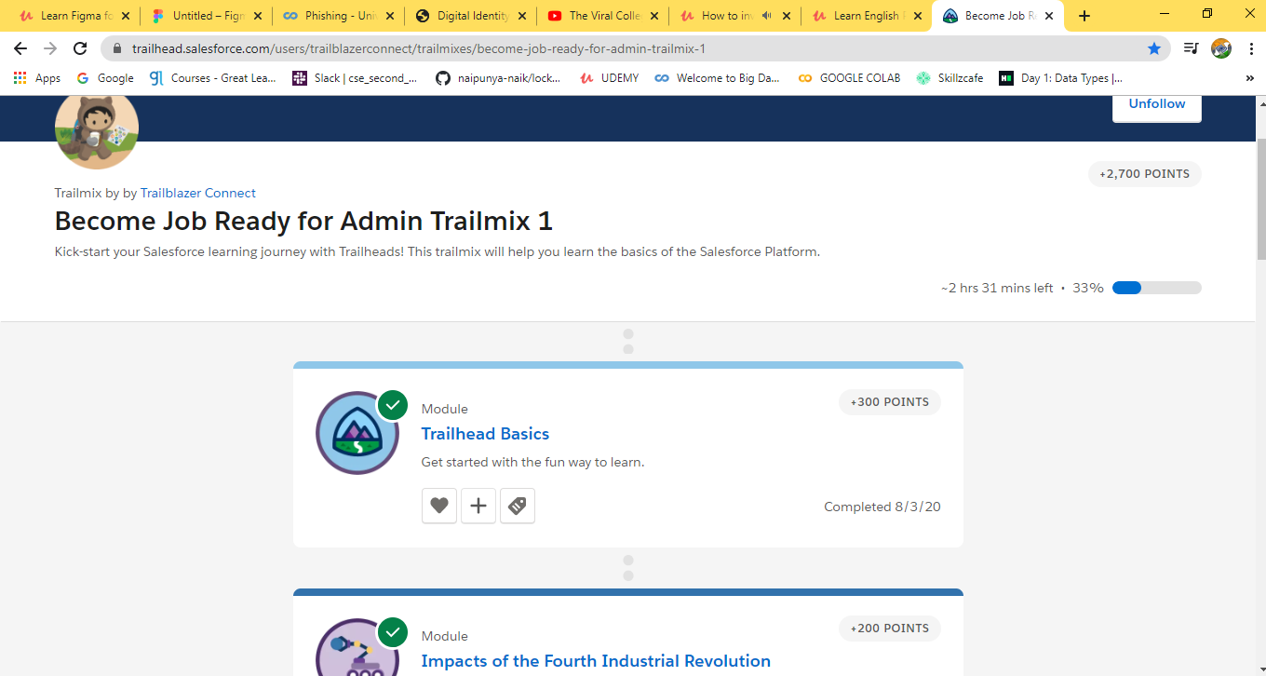

TODAY I STARTED A NEWCOURSE ON SALESFORCE , I HAVE EARNED 5 BADGES AND HAVE SCORED 925 POINTS.

# 2)CERTIFICATION COURSE NAME:- Cyber Threats and Attack vectors

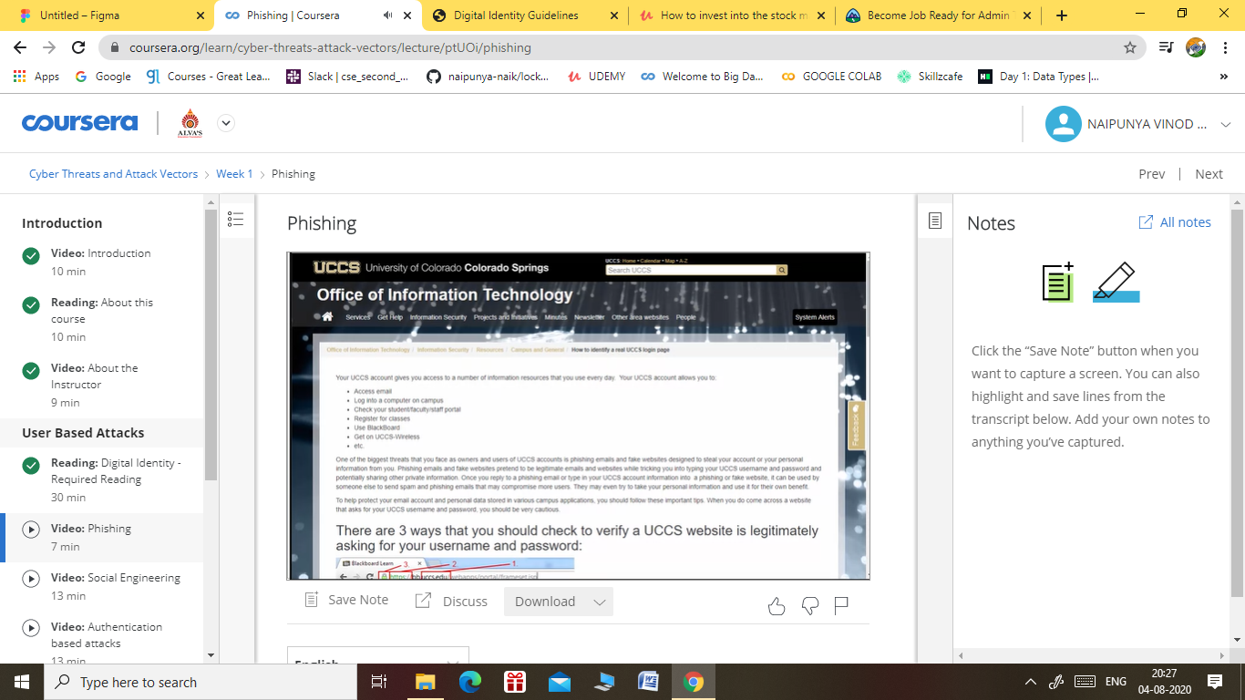

TODAY I HAVE STARTED A NEW COURSE ON COURSERA THAT IS CYBER THREATS AND ATTACK VECTORS.

Coding Challenges Details: (Attach the snapshot and briefly write the report for the same).

NO CODING CHALLENGES GIVEN TODAY